***FUNDAMENTALS OF PROGRAMMING***

***LAB MANUAL(HOME TASKS )# 6 TASKS***

**NAME:Daniyal Ahmed**

**CMS:457165**

**CLASS:ME-15**

**SECTION:B**

**DATE:20/11/2023** 

**TASK 1**

#include <iostream>

using namespace std;

int main()

{

int n,sum=0;

for(int n=2;n<=50;++n){

bool prime = false;

for(int i=2;i<=n/2;++i){

if(n%i==0 ){

prime = true;

break;

}

}

if(prime==false){

sum+=n;

}

}

cout<<"The sum of all the prime numbers from 1 to 50 is "<<sum;

return 0;

}

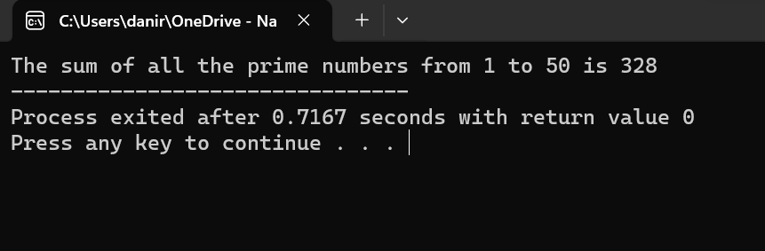

**TASK 2**

#include <iostream>

using namespace std;

int main()

{

int rows,j=1;

cout<<"Enter number for rows pattern : ";

cin>>rows;

for(int i=1;i<=rows;++i){

for(int j=1;j<=i;++j){

cout<<j;

}cout<<endl;

}

return 0;

}

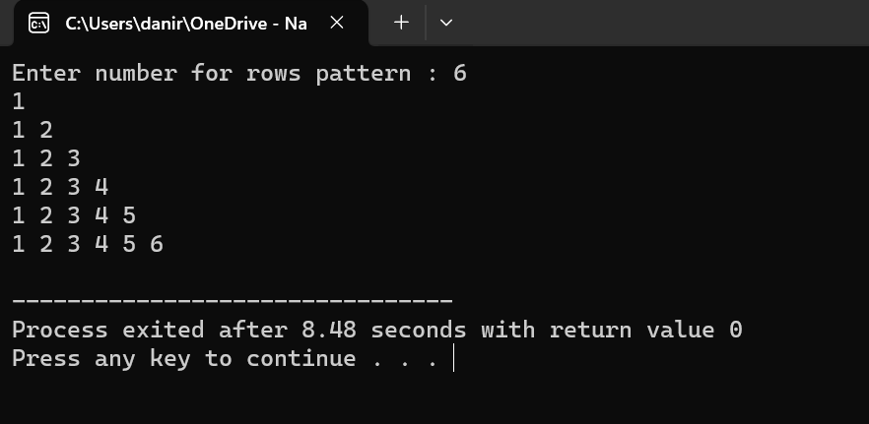

**TASK 3**

#include <iostream>

using namespace std;

int main()

{

int rows,j=1;

cout<<"Enter number for the sequence : ";

cin>>rows;

for(int i=1;i<=rows;++i){

for(int j=1;j<=i;++j){

if(i==1 || i%2==0){

cout<<i<<" ";

}

}

if(i%2!=0 && i!=1){

continue;

}

cout<<endl;

}

return 0;

}

